**VALIDATION TESTING**

**DATA:** Loop that allows user to place another order was broken

**RESULTS:** 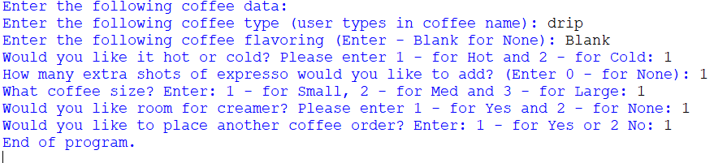

**CHANGE:** Had to correct and issue with the coding under the main loop. 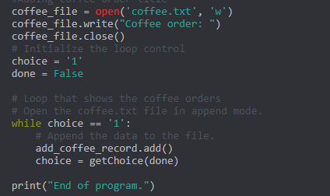

**SCREEN SHOT:**

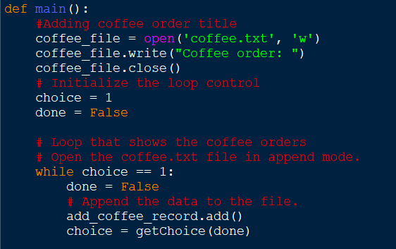

**DATA:** Function that allowed the user to enter the menu option for hot or cold. Didn’t process correctly. Was missing the int before the input statement.

**RESULTS:** 

**CHANGE:** Had to add the validation code

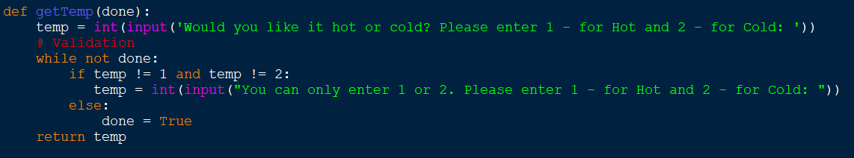

**SCREEN SHOT:**



**DATA:** Needed to ensure that the user would get an error if inputted a negative number for the Espresso Shot.

**RESULTS:**



**CHANGE:** Changed the coding to have an error inputting a negative Espresso Shot.

**SCREEN SHOT:**

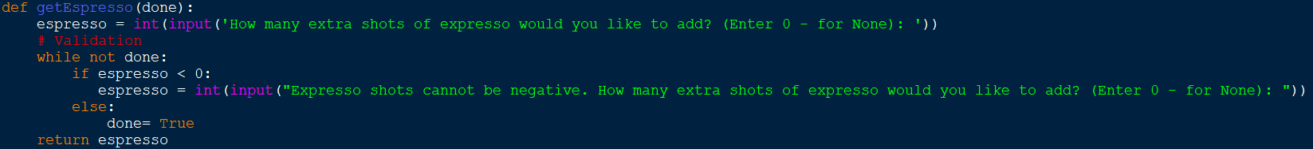

**DATA:** Needed to ensure that the user would get an error if inputted an invalid number for the menu option for sizes.

**RESULTS:** 

**CHANGE:** 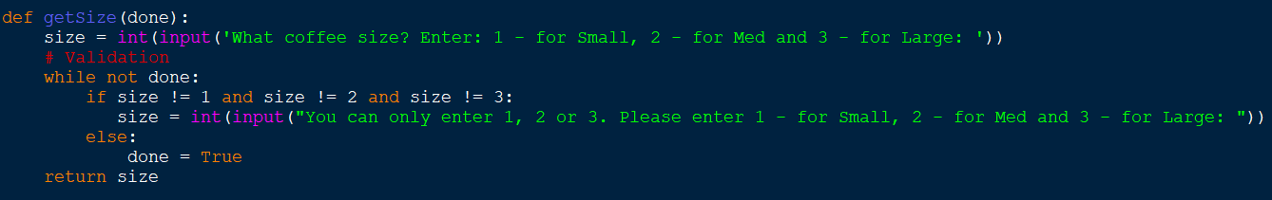

**SCREEN SHOT:** 

**DATA:** Needed to ensure that the user would get an error if inputted an invalid number for the menu option for creamer.

**RESULTS:** 

**CHANGE:** 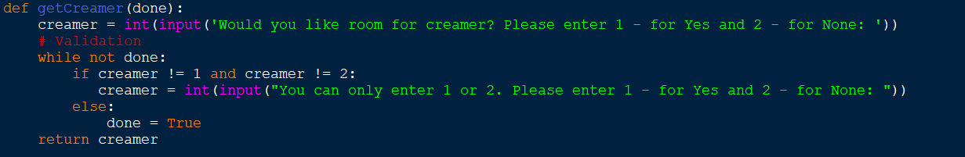

**SCREEN SHOT:**

